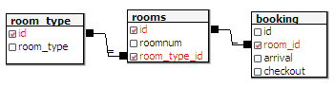

SELECT

room_type.id as room_type_id,

 room_type.room_type as room_type,

rooms.roomnum as room_number,

booking.arrival,

booking.checkout,

booking.id as booking_id

FROM

booking,

rooms,

room_type

WHERE

booking.room_id = rooms.id AND

rooms.room_type_id = room_type.id;

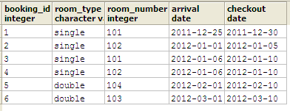UPDATED SQL STATEMENT

SELECT

booking.id as booking_id,

room_type.room_type as room_type,

rooms.roomnum as room_number,

booking.arrival,

booking.checkout

FROM

booking,

rooms,

room_type

WHERE

booking.room_id = rooms.id AND

rooms.room_type_id = room_type.id;

CREATE VIEW **rooms_reserved** AS

SELECT room_booking.room_id, room_booking.date_booking_from, room_booking.date_booking_to

FROM room_booking

WHERE room_booking.date_booking_from BETWEEN '2011-12-25'::date AND '2011-12-30'::date - 1

OR date_booking_to -1 BETWEEN '2011-12-25'::date AND '2011-12-25'::date

OR room_booking.date_booking_from < '2011-12-25'::date AND date_booking_to - 1 > '2011-12-25'::date - 1

CREATE OR REPLACE VIEW **rooms_available** AS

SELECT room.roomnum, room.id

FROM room

LEFT JOIN rooms_reserved ON room.roomnum = rooms_reserved.room_id

WHERE rooms_reserved.room_id IS NULL;